**Meeting Shelly, canine star of the Castle Hill Markets**

Posted on November 29, 2013

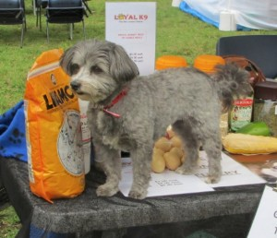

Market star, Shelly.

From my stall at the [Castle Hill Artisans Market](http://www.blackcastleevents.com.au/CastleHill.aspx) I can look past other marquees across the market and spy an intriguing sight. On a stall that sells homemade health food for dogs a small star shines her way through the day. A pint-sized little dog trots back and forth along the stall’s tables entertaining customers with her endearing smiles and willingness to be cuddled and admired.

At last weekend’s market, before the deluge, the force of this dear little dog’s personality drew me towards her and I headed over to make her acquaintance.

At [LOYAL K9 Health Food](http://loyalk9.com.au/) I met Craig who introduced me to the much-adored and highly adorable Shelly. The poor man is used to being outshone by his dog but she’s an unbeatable advertisement for the quality of his dog food.

Shelly is an eight year old Shih Tzu, Maltese cross. Craig gave her as a tiny puppy to his son, Joshua, as a fourth birthday present. Joshua named her after the shells he loved to collect on the beach and the pair have been almost inseparable ever since. Shelly sleeps on Joshua’s bed and follows him everywhere – sometimes even into the shower!

But there is one thing Shelly is prepared to do without Joshua. She LOVES going to markets.

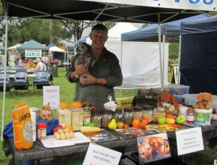

Craig is used to being outshone

Craig told me she knows which days are market days and will wake as early as 2:00am to urge him to make a start. Once at the stall she tirelessly delights and entertains the customers, charming them with her good looks and the warmth of her personality.

Craig told me he’s even had weary parents tell him their children have insisted the family makes a trip to the markets he attends – not to buy anything, simply to see Shelly!

It was a pleasure to meet Craig and Shelly and hear their story.

Filed under [Dogs](http://www.featherflowerbrush.com.au/category/small-farm-stories/dogs/), [Markets](http://www.featherflowerbrush.com.au/category/small-farm-stories/markets/), [Small Farm Stories](http://www.featherflowerbrush.com.au/category/small-farm-stories/)